CS 340 README

About the Project/Project Title
This Python module serves as the middleware between a frontend application and a MongoDB database. It enforces CRUD principles when altering or accessing data in the database by containing methods for each CRUD operation and allows performing these actions on the specified database. Having this middleware between the database and a frontend application provides control over how data is created, updated, read, and deleted. This additional verification enhances the application's security and functionality by handling the code required to perform various CRUD operations.

Motivation
A middleware module is necessary to connect the project's front end to the MongoDB database, ensuring that new data is added correctly and that old data is read, updated, or deleted correctly as well. Having a middleware module also provides additional security, since the frontend will never interact directly with the database; instead, all interactions must first pass through this module, where the various actions are strictly controlled and tested before being passed to the database. Additionally, creating this module makes it easier to reuse the CRUD methods across multiple projects, as rather than having to redefine them in each project, one can import this module and access the necessary CRUD methods without much hassle.

Getting Started
To use this module in a project, certain actions must be taken before accessing and using it. First, set up the MongoDB database by creating a database and adding a collection to it. For this module, the default database name is "aac," and the default collection name is "animal." The next step is to create a user for the module to access the database, which entails creating a user, assigning a username and password, and granting the necessary role to read and write to the newly created database. The default username and password for this module are "aacuser" and "SNHU1234", respectively. Once the database and user are set up, the module can be loaded and, if desired, edited with different database and user information. To change this information, update the constructure by replacing the current variable data in the AnimalShelter's init method such as "USER," the new accounts username, "PASS," the new account's password, "HOST," the IP address of the system hosting the MongoDB database, "PORT," the port the MongoDB database is exposed to, "DB," the name of the database, and "COL," the name of the collection.
The creation and read methods provided in this module were created using this database connection, utilizing functions from a module called "Pymongo," which is used as an interface between MongoDB and Python. With this, various methods can be called on the database connection to perform their necessary actions. The most difficult aspect of creating these methods was finding a way to make them multi-purpose, avoiding the need for multiple functions that behave slightly differently. For instance, instead of having two separate read commands, one to gather all documents from the database and another to gather specific documents from the database, their functionality was combined by using a parameter and basing the read action on the filter query. A similar occurrence happened with the create method, since rather than having a create one or create multiple, a list parameter is used that can accept either a single entry or multiple entries.

Installation
Using this module requires running a MongoDB database, which can be performed in one of two ways. One is to use a cloud database for MongoDB, with multiple providers offering the necessary information to access it upon purchase, and the second is to host the database on a local machine. The latter requires downloading and installing MongoDB from their site. There are currently two options, community or enterprise edition, but for this module, the community edition was used. Additionally, Python must be installed on the system running this module, and it must be version 3.14.3 or greater; 3.14.3 is the latest stable release at the time of writing. The installer can be found on the Python website, along with instructions for downloading it. To use the module within Python, the PyMongo library is required. PyMongo can be installed using the Python CLI by running "pip install pymongo".

Usage
Using the module entails first constructing and initializing an object from the AnimalShelter class. The constructor requires you to provide a valid username and password for the already set up MongoDB database. Additionally, if necessary, change the values for the database name, collection, port, and host address in the constructor to match your MongoDB setup. The module initially runs pointing towards your system's "localhost" address and to port 27017, and towards a database name of "aac" and a collection within it titled "animals." Once the object is initialized, the various methods for creating, updating, reading, and deleting will be available, along with two other methods. One of these methods is to obtain the next "rec_num" for use in the creation of new documents, and to perform a database connection test to validate the connection before use.
Using the various CRUD methods entails calling the methods and passing the necessary parameters to query or insert data into the database properly. The creation method requires passing in a list of documents that contains at least one document to be inserted into the database. For this document, an additional method, getNextRecNum(), will be used to query the database for the next available rec_num based on the current highest value for the field. Thus, all documents passed into the method will have an appropriate rec_num based on the current documents in the collection. The read method takes an optional query filter and uses it to find matching documents; if no filter is provided, all documents in the database are returned.

Code Example
# Read method to view documents from the database
# a query filter can be passed in to view only specific documents
def read(self, filterQuery):
if filterQuery is None:
# Returns a list of all documents
return list(self.collection.find({}))
else:
# Returns a list of all documents matching the passed in query filter
return list(self.collection.find(filterQuery))

The code above is the read method in the module that allows access to all documents in the database or to filter the database using a query. This method has dual functionality, allowing the gathering of all documents and filtering the database, eliminating the need for separate methods. Which is similar to the other methods in the module, in that they also have multiple features implemented, such as the create method, which allows creating a single document or multiple documents at once. These methods greatly reduce the amount of code needed to perform these actions on the database and encapsulate them into a single method for use throughout an entire program.

Tests
Multiple tests can be run to validate the module and ensure it is properly configured to work with the MongoDB database and perform all CRUD operations properly. It is recommended to start with a database connection test using the con_test() method. This method returns a string indicating whether the database connection was successful or an issue occurred; in the successful case, the string reads "Connection successful."

## Tests the connection to the database
print("Connection Test:")
print(db.con_test())

### Output:
## Connection Test:
##Connection successful

The code above shows how to test for a successful connection using the method; in this case, the object constructed from the AnimalShelter class is stored in the "db" variable. The returned value indicates that a successful connection was created and the test method succeeded.
Testing the creation method is another straightforward process that involves creating one or more dummy records. Regardless, the document or documents must be contained within a list. The creation method returns a Boolean value indicating whether the creation was successful or an issue occurred. Note that if multiple documents are passed in, and one fails to be inserted, the Boolean will return false.

## Tests the creation of documents to the database
print("Insert Test")
dummyRecs = [{
'name': 'Test Dog',
'breed': 'Test Breed',
'age': 2
}, {
'name': 'Test Dog #2',
'breed': 'Test Breed',
'age': 2
}]

# Calls the method to create a new document using the dummy record list
print(db.create(dummyRecs))

# Prints the newly created document
print("Read New Document:")
print(db.read({
'breed': 'Test Breed',
}))

### Output:
## Insert Test
## True
## Read New Document:
## [{'_id': ObjectId('69c6e3c8cdbeb1733e24022e'), 'name': 'Test Dog', 'breed': 'Test
## Breed', 'age': 2, 'rec_num': 10001}, {'_id': ObjectId('69c6e3c8cdbeb1733e24022f'),
## 'name': 'Test Dog #2', 'breed': 'Test Breed', 'age': 2, 'rec_num': 10002}]

The above code shows the process of adding two new documents to the database and a read test to verify that they were correctly added and are accessible. The initial create method returned true, indicating that the creation succeeded. Still, it is recommended to display the database documents to validate that the method for obtaining the next "rec_num" value is obtaining the proper value. As shown in the output, it was also successful in this instance, as a rec_num of "10001" was added to the first new document, a value of "10002" was added to the second new document, and the database contained 10000 documents before adding the new one.
Testing the read method involves validating that all documents matching the passed-in query filter are returned, or that, if no query filter is passed, all documents are returned.

# Calls the read method to access all documents
print("Read All Records:")
rec = db.read(None)

print("Returned Number of Docs: ")
print(len(rec))
# Prints the first five documents in the list
for i in range(5):
print(rec[i])

# Calls the read method to access documents matching the query filter
print("Read By Breed:")
rec = db.read({"breed": "Labrador Retriever Mix"})

# Prints the first five documents in the list
for i in range(5):
print(rec[i])

### Output (Truncated):
## Read All Records:
## Returned Number of Docs:
## 10002
## {'_id': ObjectId('69b9c86261cb802d539322bc'), 'rec_num': 1, …
## {'_id': ObjectId('69b9c86261cb802d539322bd'), 'rec_num': 9, …
## {'_id': ObjectId('69b9c86261cb802d539322be'), 'rec_num': 10, …
## {'_id': ObjectId('69b9c86261cb802d539322bf'), 'rec_num': 11, …
## {'_id': ObjectId('69b9c86261cb802d539322c0'), 'rec_num': 4, …
## Read By Breed:
## {'_id': ObjectId('69b9c86261cb802d539322bd'), 'rec_num': 9, …
## {'_id': ObjectId('69b9c86261cb802d539322cb'), 'rec_num': 5, …
## {'_id': ObjectId('69b9c86261cb802d539322ce'), 'rec_num': 22, …
## {'_id': ObjectId('69b9c86261cb802d539322e6'), 'rec_num': 50, …
## {'_id': ObjectId('69b9c86261cb802d539322f5'), 'rec_num': 36, …

The code above shows how to test the read method; two tests are required. The first validates that reading all records is functioning, and the second validates that reading with a filter query is functioning as well. For the first test, a check is made to ensure that the correct number of documents is returned when no query filter is provided, which should equal the total number of documents in the database collection. The output shows that the first test was since the first indicated that the correct number of documents were returned. The second test is validated by listing the first five records returned by each method call. The first set is from reading all documents, and the second is from reading documents using a filter query. The first five documents from each set were displayed on the screen, and this validates the second test as the "rec_num" values for the first five differ when using the query filter as opposed to using none. Additionally, the second set contains documents that match the specified filter.

Screenshots

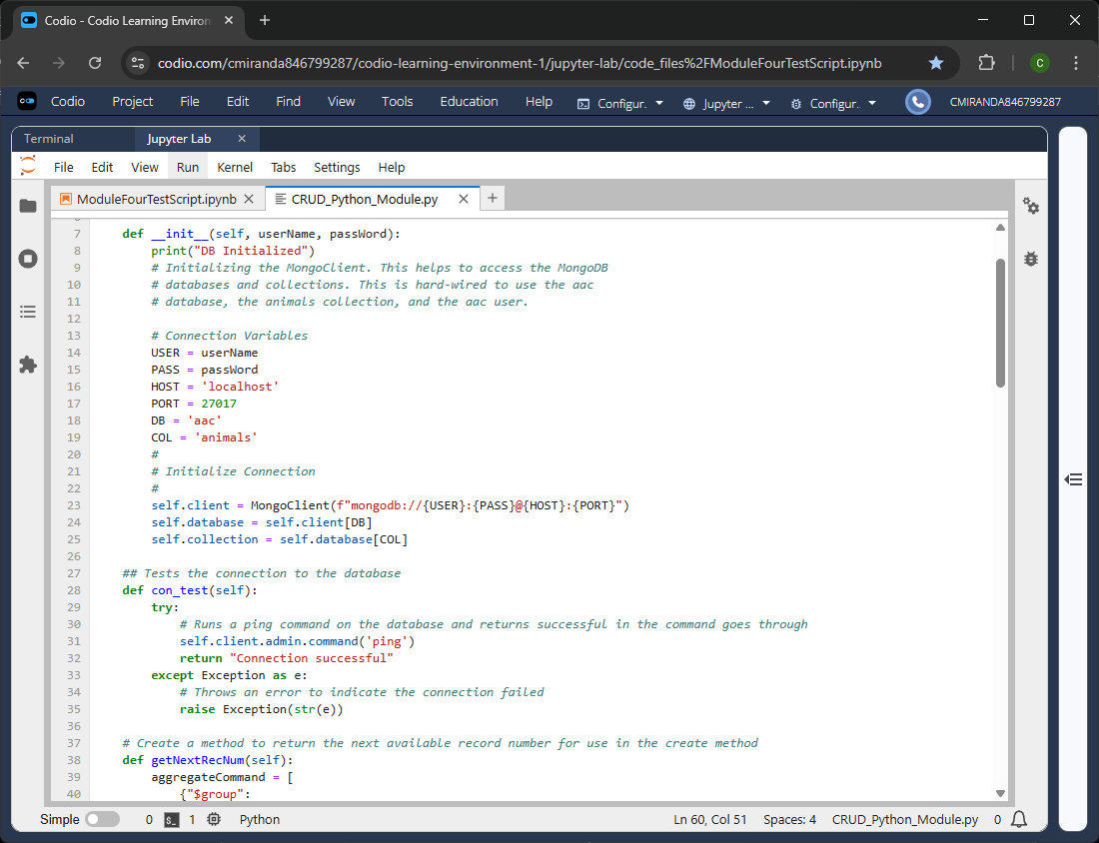
Figure 1 – The constructor for the AnimalShelter class that contains the variables defining the database connection that will need to be adjusted based on the user’s setup for the database.
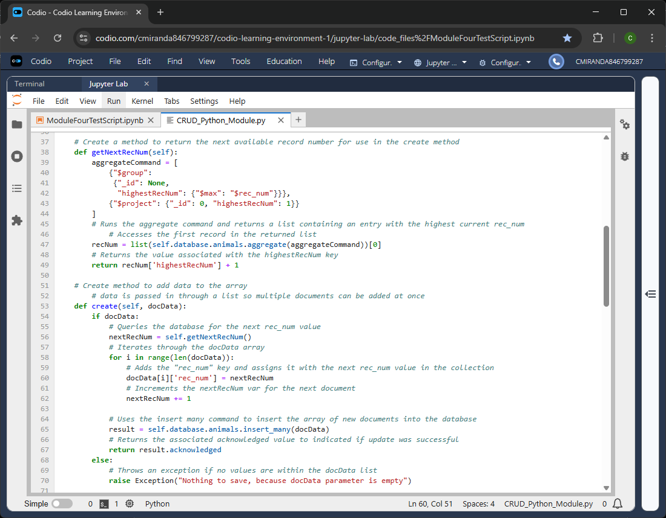
Figure 2 -The create method and its accompanying getNextRecNum method and the create method uses it to determine the next available “rec_num” when adding new documents.
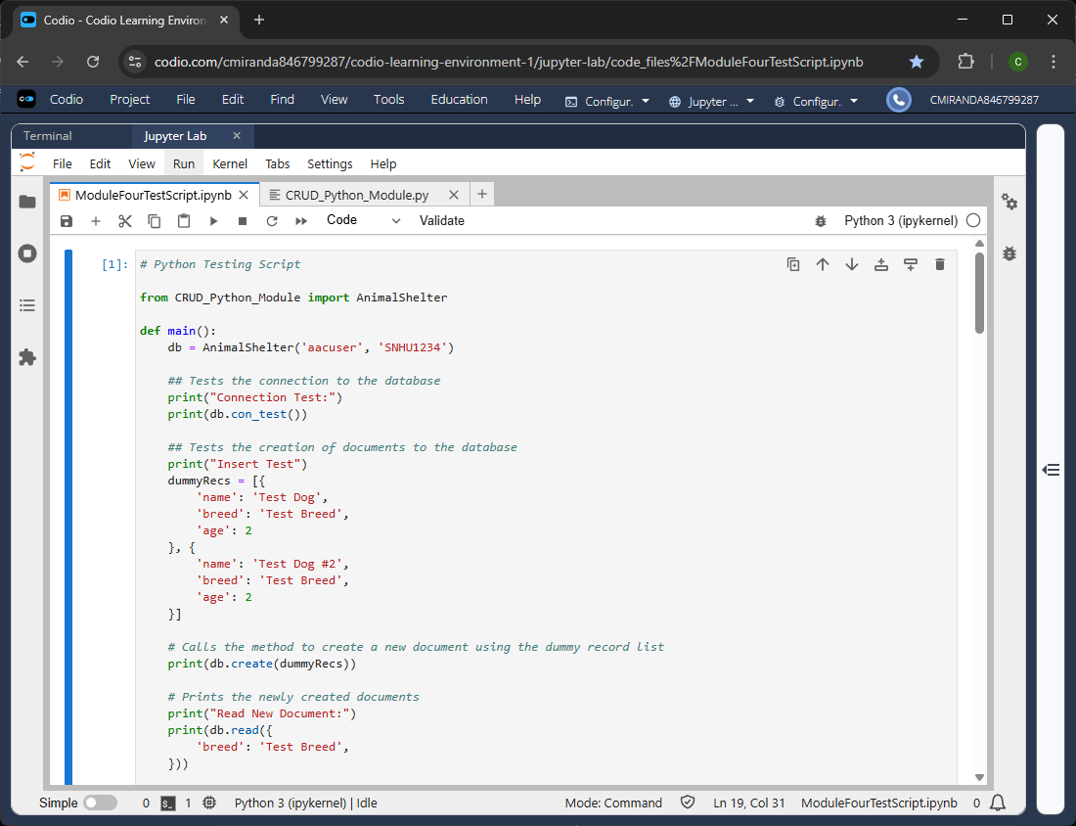
Figure 3 – Database Connection and Creation tests for validating the connection to the database and validating the creation of multiple new documents.
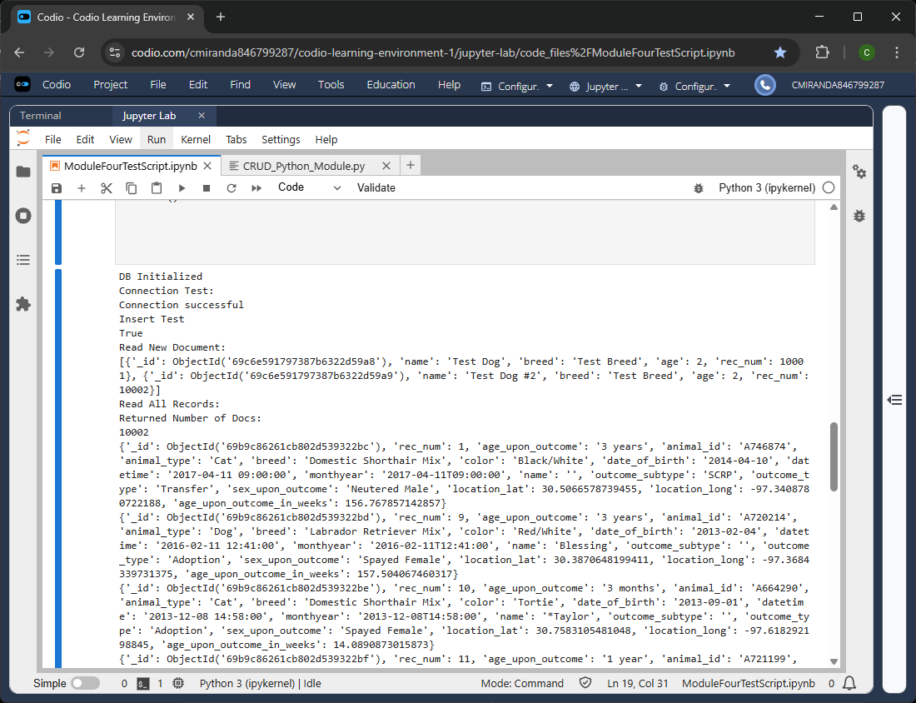
Figure 4 – Database Connection and Creation Test output that validates both methods are properly functional.
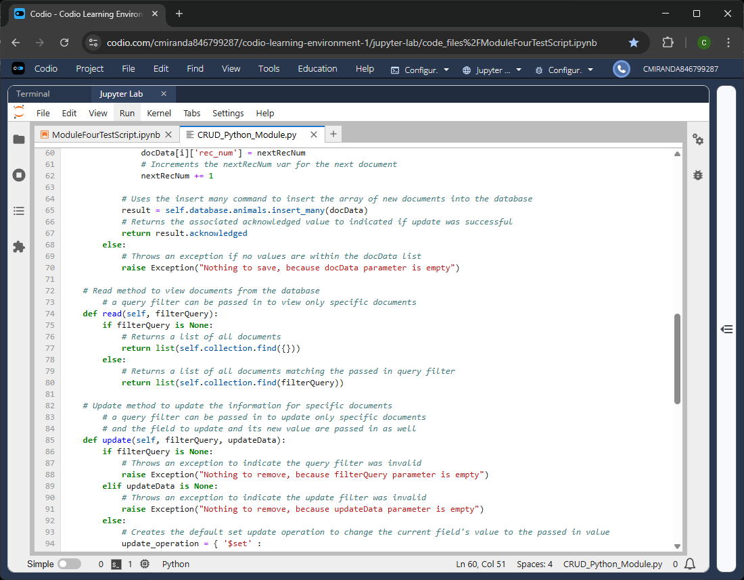
Figure 5 - The read method code that shows that reading from the database can be filtered by passing in a filter query or that all documents in the database collection can be returned by not passing one in.
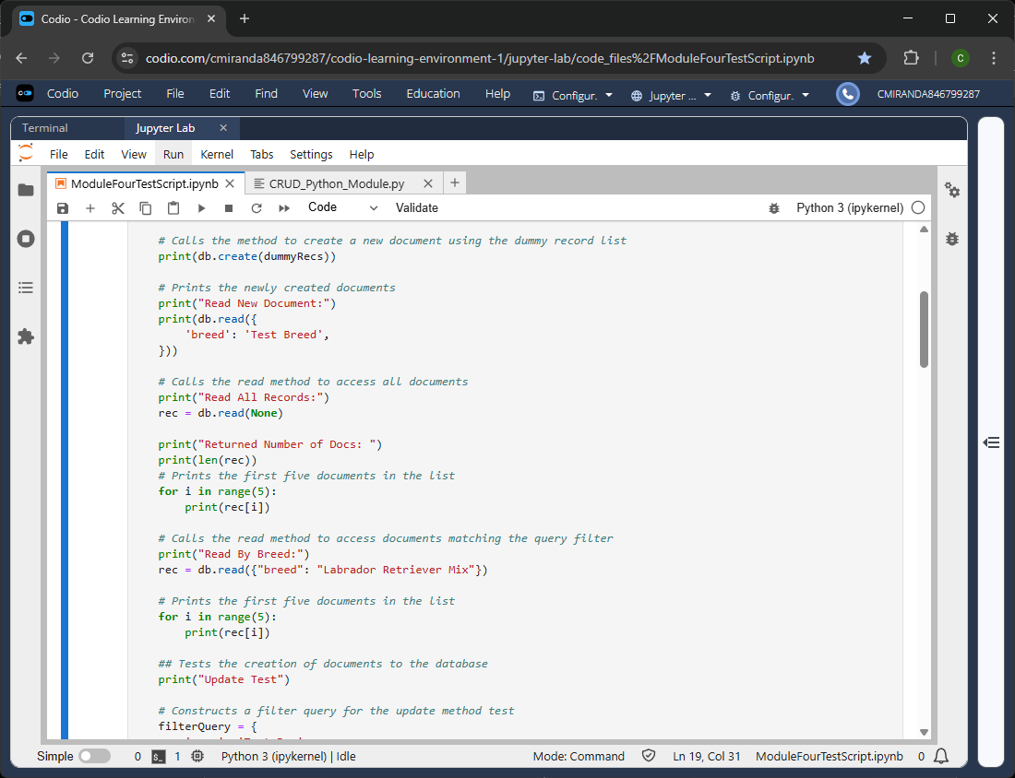
Figure 6 – Read Method Test for validating both reading the database using a filter query and reading the entire database.
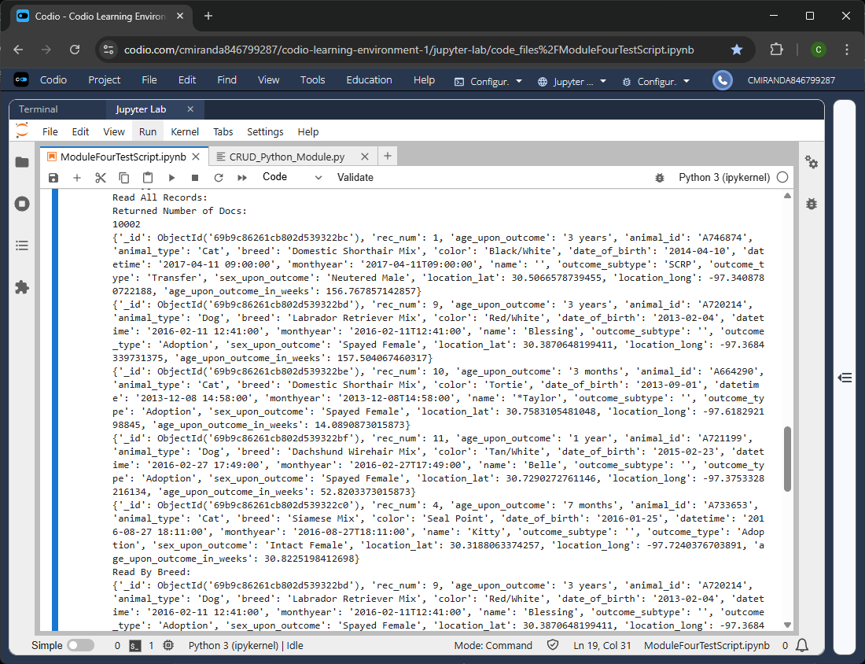
Figure 7 – Output for the read test that validates that all documents in the database are read and the first five documents are displayed.
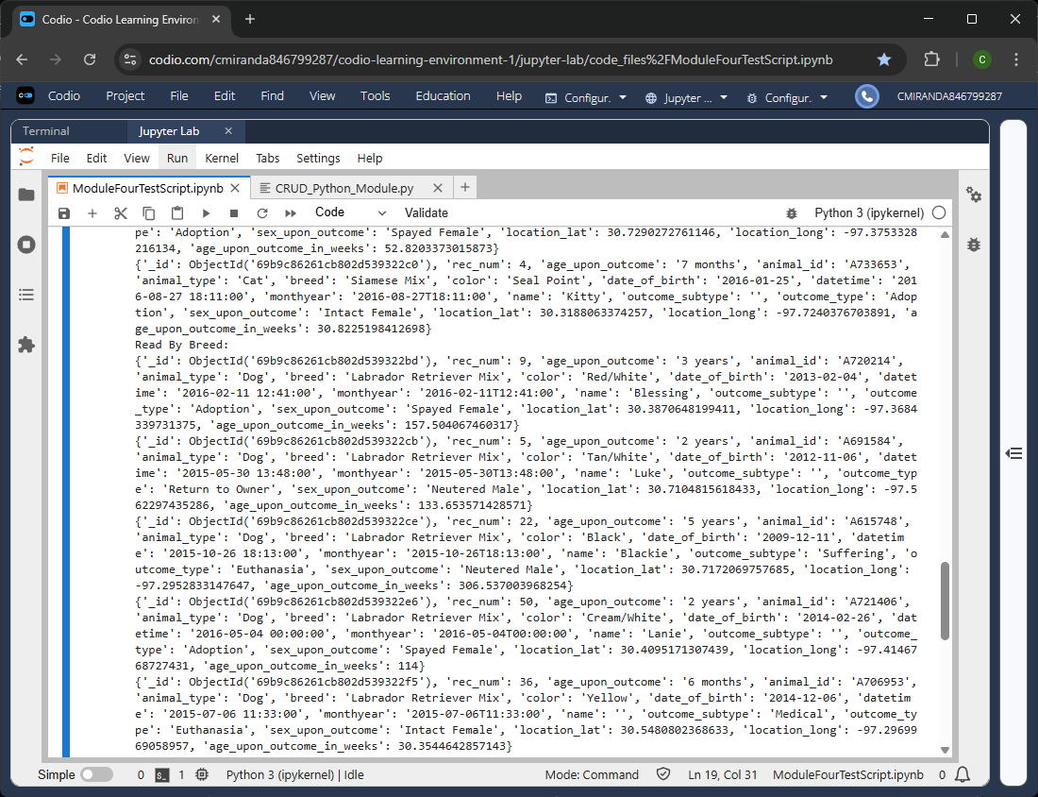
Figure 8 - Output of the read test that used the filter query, and it validates that the read method properly filter the database when retrieving the documents as they the five documents obtained are different from the first read test and they match the specified filter.

Contact
Cristiano Miranda

